Local publication for call for proposals
3rd Call for Proposals Cross-border Programme  Bosnia and Herzegovina - Montenegro  Reference: EuropeAid/170435/DD/ACT/BA | 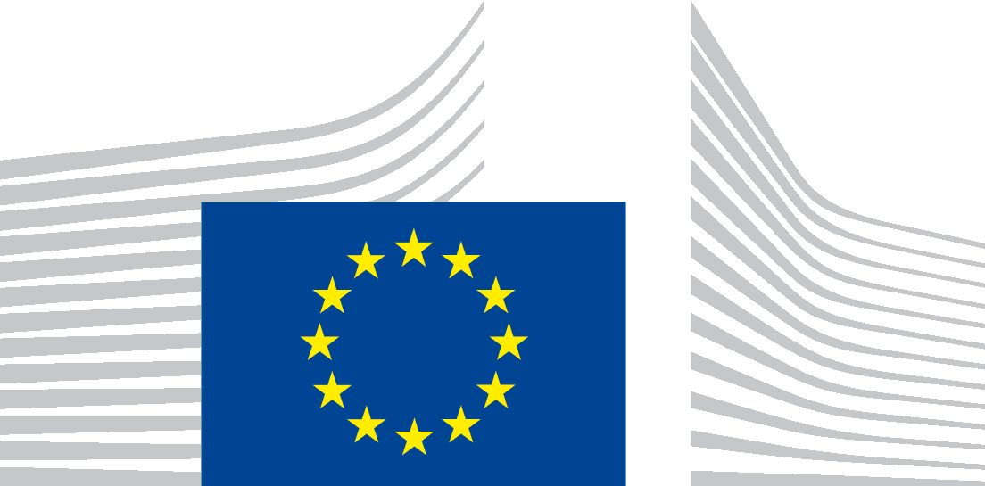
The Delegation of the European Union to Bosnia and Herzegovina is seeking proposals for the Cross-border cooperation projects in Bosnia and Herzegovina-Montenegro programme with financial assistance from the Instrument for Pre-accession 2014-2020. The full guidelines for applicants are available for consultation at http://europa.ba/?page_id=320 and on the following internet site: https://webgate.ec.europa.eu/europeaid/online-services/index.cfm?do=publi.welcome
www.cbc.bih-mne.org
www.dei.gov.ba
www.kei.gov.me

The deadline for submission of proposals is 9th February 2021 at 16.00.

An information session on this call for proposals will be held online on 12th January 2021 at 11.00.

***

